|  |  |  |  |  |  |
| --- | --- | --- | --- | --- | --- |
| Date | 9-Dec-22 | | | Tester Name | Janette Paus |
| Environment | Penfax - Test 2 | | | Login used |  |
| Operating System | Windows | Version: 21H2 | Update Number: | | |
| Software Used | Select Software | Version: 107.0.1418.56 | Update Number: | | |
| Select Software | Version: | Update Number: | | |
| Application Release version | R22.4.1 | | | | |
| Test Case Title | E20.09 | | | | |
| Test Type | Regression | | | | |
| Test Scenario | Adjust a member deposit | | | | |
| Expected Results | Update effective date in member deposit, ensure that breakage is attributed to the transaction according to the updated date (not the original date). | | | | |
| Pass/Fail | Pass | | | JIRA# |  |

Search any PEPP member, deferred or active with money in their account.

SID: 275078

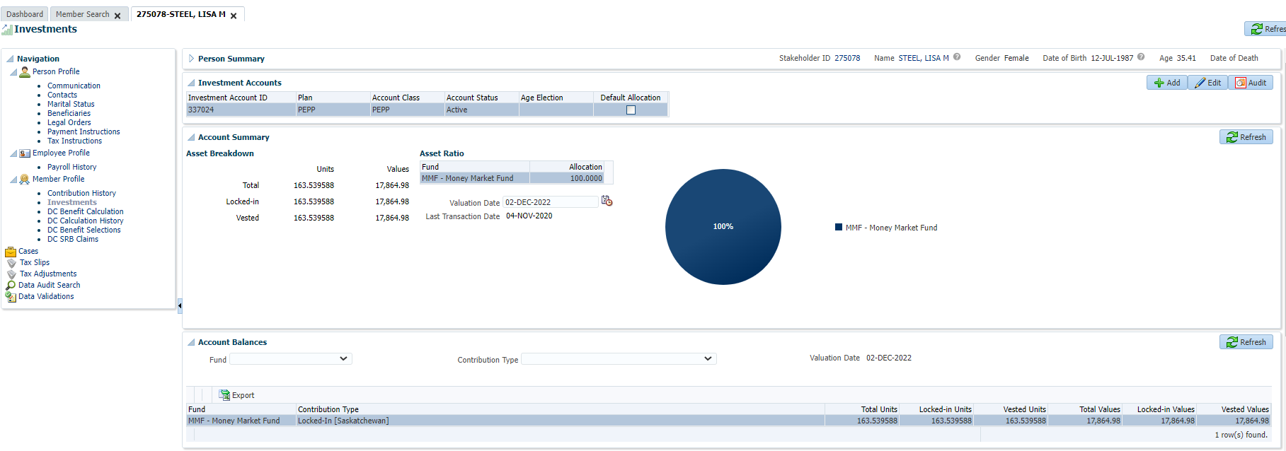

Create Remittance:

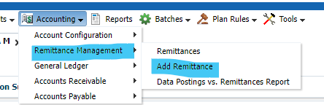

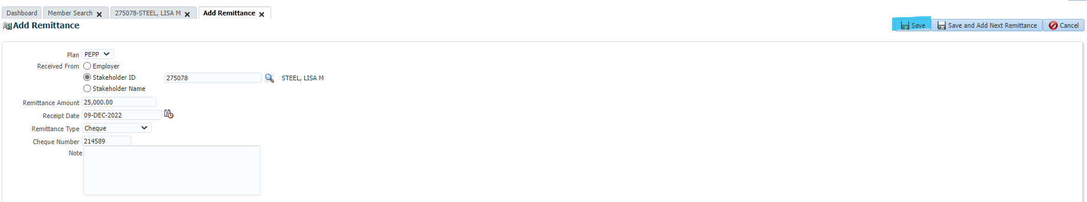

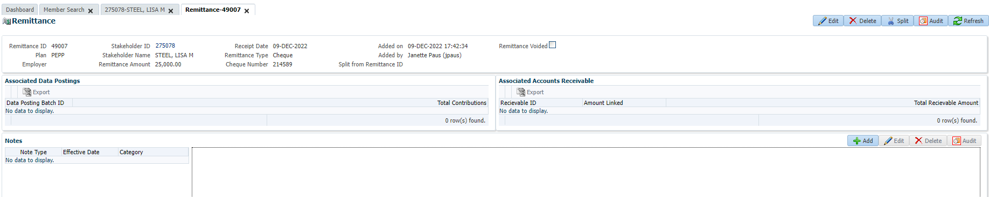

Process Deposit:

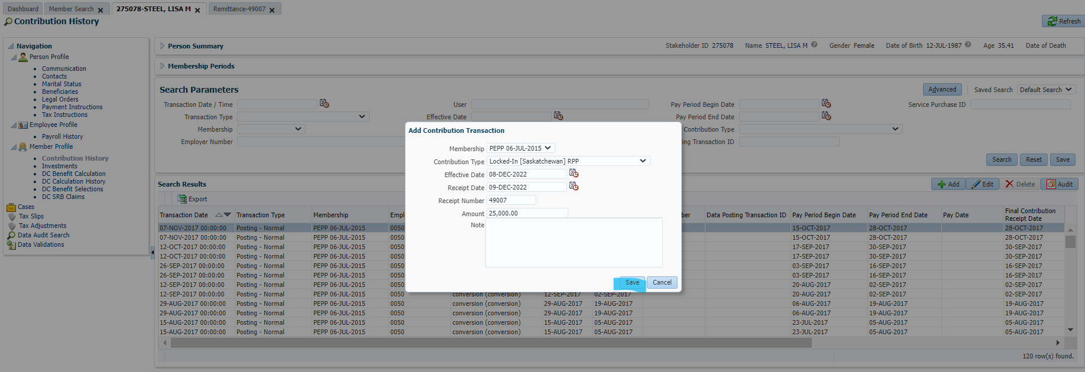

Highlight the record and click Edit:

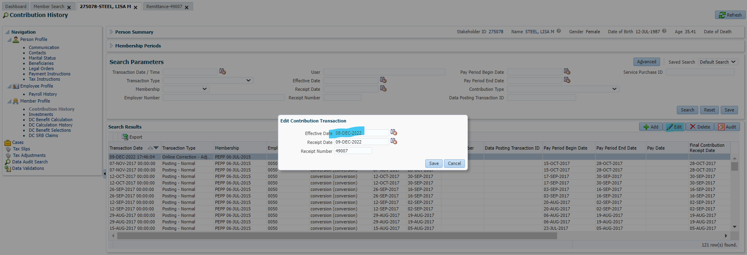

Change effective date from Dec 8, 2022 to Dec 9, 2022.

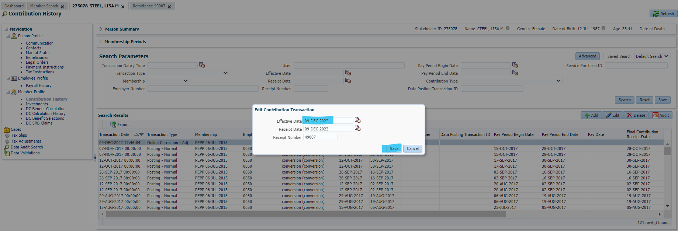

Next day: confirm that no breakage occurred and that date funds were deposited is Dec 9 (not Dec 8).

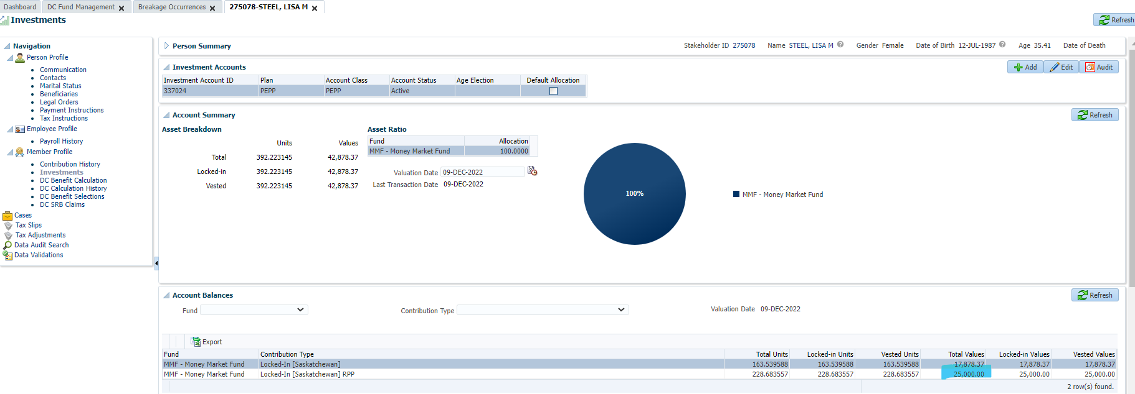

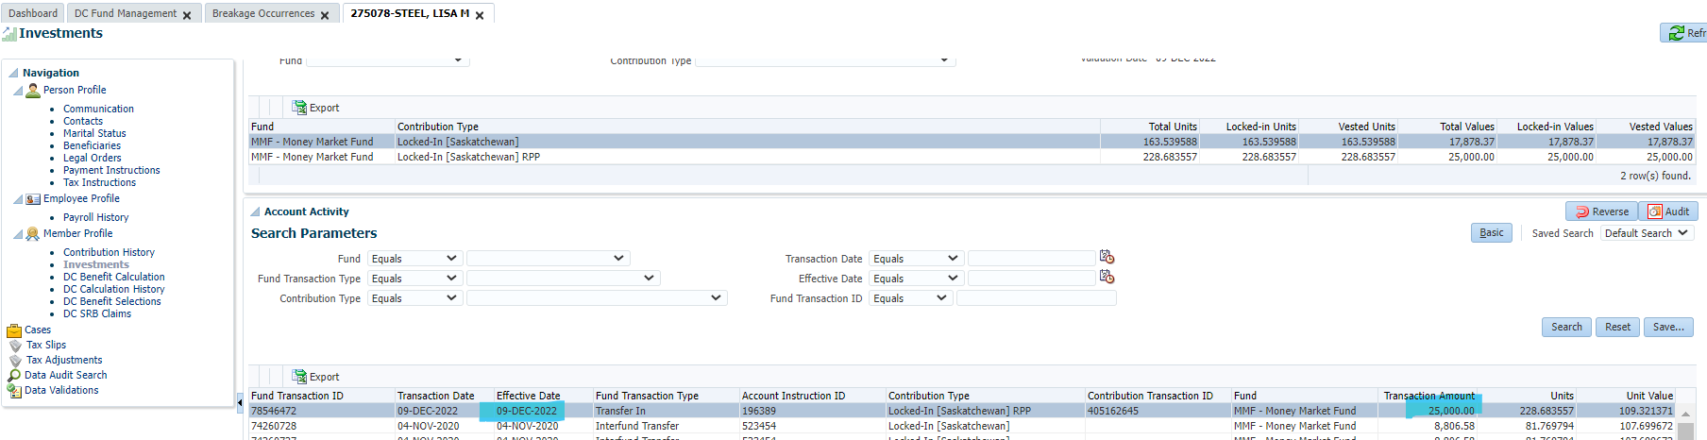

Contribution history effective date showing as Dec 9 still:

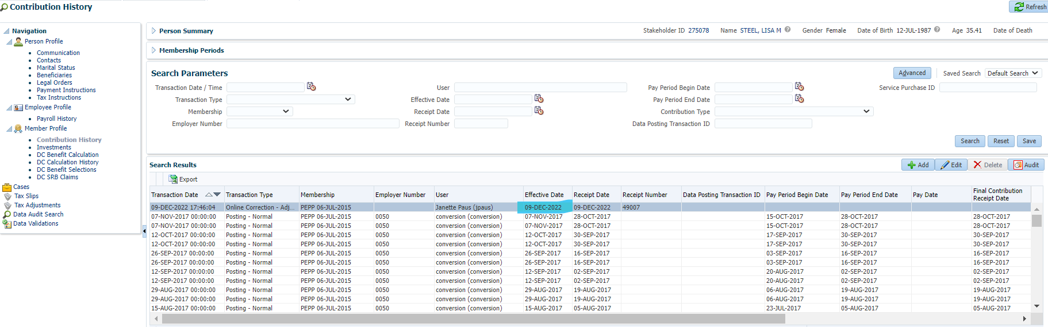

Confirming that the effective date is still showing as Dec 9 & Dec 9unit values were used.

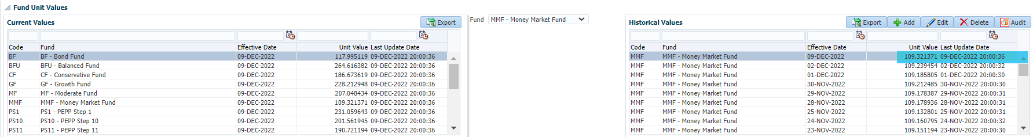

Confirming no breakage:

